Module 1: The Bedrock (Mathematical & Analytical Foundations)
Before touching code, you need to understand the language ML speaks.
- Linear Algebra: Vectors, matrices, matrix multiplication, eigenvalues, and eigenvectors (the core of how data is represented).
- Calculus: Derivatives, partial derivatives, and the Chain Rule (how algorithms learn and optimize).
- Probability & Statistics: Probability distributions, Bayes' Theorem, mean/variance, and hypothesis testing (how algorithms handle uncertainty).

Module 2: Introduction to ML & Data Preprocessing
Garbage in, garbage out. A pro knows that data preparation is 80% of the work.
- The ML Landscape: Supervised vs. Unsupervised vs. Reinforcement Learning.
- Features & Targets: Understanding independent (X) and dependent (y) variables.
- Data Cleaning: Handling missing values, outliers, and duplicates.
- Feature Engineering: One-Hot Encoding (categorical data) and Feature Scaling (Standardization vs. Normalization).
- Data Splitting: The golden rule of Training, Validation, and Testing sets.

Module 3: Core Optimization Mechanics (The "Learning" in ML)
How do machines actually learn from data?
- Loss Functions: Quantifying error (Mean Squared Error for regression, Cross-Entropy for classification).
- Gradient Descent: The ultimate optimization algorithm (Intuition, learning rates, and how it finds the minimum error).
- Overfitting vs. Underfitting: The Bias-Variance Tradeoff (Why a model performs perfectly on training data but fails in the real world).
- Regularization: Techniques to prevent overfitting (L1/Lasso and L2/Ridge).

Module 4: Classic Supervised Learning Algorithms
Deep-dive into the mechanics, math, and use cases of foundational algorithms.
- Linear Regression: Ordinary Least Squares, assumptions of linearity, and interpreting coefficients.
- Logistic Regression: The Sigmoid function, odds ratios, and binary classification.
- Decision Trees: Entropy, Information Gain, Gini Impurity, and how trees split data.
- Ensemble Methods: Why a crowd is smarter than an individual (Bagging/Random Forests and an introduction to Boosting).
- Support Vector Machines (SVM): Hyperplanes, margins, and the Kernel Trick.
- k-Nearest Neighbors (k-NN): Distance metrics (Euclidean, Manhattan) and instance-based learning.

Module 5: Unsupervised Learning (Finding Hidden Patterns)
Learning from data that doesn't have labels.
- Clustering: k-Means (centroids, Elbow method) and Hierarchical Clustering.
- Dimensionality Reduction: Principal Component Analysis (PCA) — compressing data without losing vital information.

Module 6: Evaluation Metrics (Measuring True Success)
How to prove your model actually works.
- Regression Metrics: R2 Score, MAE, RMSE.
- Classification Metrics: The Confusion Matrix, Accuracy, Precision, Recall, F1-Score, and ROC-AUC curves.
- Cross-Validation: k-Fold validation to ensure your metrics are reliable and not just lucky.

Where should we start?
Now that you have the complete map, we can tackle this one step at a time to ensure a crystal-clear, detailed understanding.
Which module or specific topic from this list would you like to dive into first?

1. Mathametical & Analytical

- Linear algebra

Linear algebra is a core mathematical foundation for machine learning, as most datasets and models are represented using vectors and matrices.

Data in ML is represented as vectors (features) and matrices (datasets).
- perations like dot product, matrix multiplication and transformations power ML algorithms.
- Key concepts such as eigenvalues, eigenvectors and decompositions simplify dimensionality reduction, optimization and training.
- Algorithms like PCA, SVD, regression, SVMs and neural networks rely heavily on linear algebra.

Fundamental concepts of Linear Algebra:
1. Vectors (Both Magnitude & Direction)
2. Matrices
3. scalars (Only Magnitude)

operations of Linear Algebra:

1. Linear Transformation;
Linear Transformation are basic operations in linear algebra that change vectors and matrices while keeping important properties like straight lines and proportionality. In machine learning, they are key for tasks like preparing data, creating features and training models. This section covers the definition, types and uses of linear transformations.
Definition: A transformation T is linear if it satisfies:
- Additivity: T(u+v) = T(u)+T(v)
- Homogeneity: T(kv) = k T(v)
Common Types in ML
- Translation : Centering data by subtracting the mean.
- Scaling : Normalizing features so no single feature dominates.
- Rotation : Turning data, often used in computer vision and robotics.

2. Eigenvalues and Eigenvectors
Eigenvalues and eigenvectors describe how matrices transform space, making them fundamental in many ML algorithms.
- Eigenvalues (λ): Scalars showing how much a transformation stretches or compresses along a direction.
- Eigenvectors (v): Non-zero vectors that only scale (not change direction) under transformation.
Applications in ML:
  - Dimensionality Reduction (PCA): Keeps directions with largest eigenvalues (most variance).
  - Matrix Factorization (SVD, NMF): Breaks large datasets into smaller, structured parts for feature extraction.

3. Solving Linear Systems of equations
Linear systems are common in machine learning for parameter estimation and optimization. Key methods include:
1. Gaussian Elimination: Transforms a matrix into row-echelon form using row operations. Steps:
- Forward Elimination -> make entries below diagonal zero
- Back Substitution -> solve variables from last row upward
- Pivoting -> swap rows to avoid division by zero
2. LU Decomposition: Splits a matrix into Lower (L) and Upper (U) triangular matrices. Solves systems efficiently using forward and back substitution.
3. QR Decomposition: Splits a matrix into Orthogonal (Q) and Upper triangular (R). Useful for least squares problems and eigenvalue computation.

4. Application of Linear Algebra Machine Learning
PCA (Principal Component Analysis): Reduces dimensionality by computing covariance, eigenvalues/eigenvectors and projecting data onto principal components.
- SVD (Singular Value Decomposition): Factorizes a matrix into A = UΣVT, used for dimensionality reduction, compression and noise filtering.
- Linear Regression: Models relationships via matrix form Y = Xβ+ ϵ, solved using the normal equation XTXβ = XTY.
- SVM (Support Vector Machines): Uses the kernel trick and optimization to find decision boundaries for classification and regression.
- Neural Networks: Depend on matrix multiplications, gradient descent and weight initialization for training deep models.

- Calculus
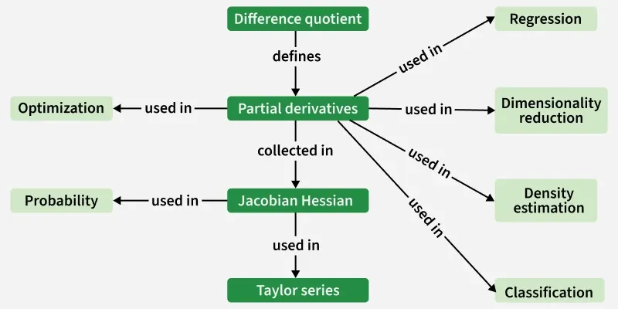

Calculus is a key tool in developing machine learning algorithms and models. It offers a mathematical framework for describing how machines learn and optimize their performance.

Function Approximation: Used when exact solutions aren’t possible, to approximate functions mathematically. And mormally used for the optimization

Fundamental concepts of Calculus:

1. Differentiation
2. Partial Derivative
3. Gradient and Gradient Descent (is a vector showing steepest acsent of function and gradient descent uses the gradient to find the function’s minimum )
4. Chain Rule
5. Jacobian and Hessian Matrices (Used in Newton methods)

Applications of Calculus:

1. Linear Regression
2. Logistic Regression
3. Neural Network ( Backpropogation: Chain rule used to find gradient of the loss function for each weight)
4. Support Vecor Machines (calculus to find optimal seperating hyperplane)

- Probability & Statistics

Descriptive Statistics: helps us simplify and organize big chunks of data. summarize and describe the features of a dataset, providing a foundation for further statistical analysis.

1. Mean
2. Median
3. Mode
4. Range
5. Variance
6. Standarad Deviation
7. Interquartile Range
8. Skewness
9. Kurtosis (Measures the peakedness of the graph)

Inferential Statistics:

tomorrow 3rd and 8th
thursday last 2hrs
friday 1st hr

